**2.3.1 Vector Quantization**

VQ is a process of mapping vectors from a large vector space to a finite number of regions in that space. Each region is called a cluster and can be represented by its center called a centroid The collection of all code words is called a codebook.

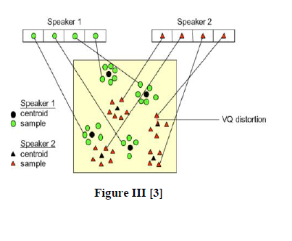

One speaker can be discriminated from another based of the location of centroid of the above figure shows a conceptual diagram to illustrate this recognition process. In the figure, only two speakers and two dimensions of the acoustic space are shown. The circles refer to the acoustic vectors from the

speaker 1 while the triangles are from the speaker 2. In the training phase, a speaker-specific VQ codebook is generated for each known speaker by clustering his/her training acoustic vectors. The result code words (centroids) are shown in above figure by black circles and black triangles for speaker 1 and 2, respectively. The distance from a vector to the closest code word of a codebook is called a VQ-distortion. In the recognition phase, an input utterance of an unknown voice is “vector-quantized” using each trained codebook and the total VQ distortion is computed. The speaker corresponding to the VQ codebook with smallest total distortion is identified.

For this Vector Equalization we use two types of distance methods

1. Euclidian Distance method

2. K-L Distance method

**2.3.2. Euclidian Distance method**

In the speaker recognition phase, an unknown speaker’s voice is represented by a sequence of feature vector {x1, x2 ….xi), and then it is compared with the codebooks from the database. In order to identify the unknown speaker, this can be done by measuring the distortion distance of two vector sets based on minimizing the Euclidean distance[6].The formula used to calculate the Euclidean distance can be defined as following: The Euclidean distance between two points

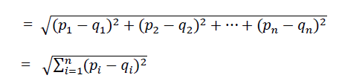

The speaker with the lowest distortion distance is chosen to be identified as the unknown person.

**2.3.3 K-L Distance Method**

In probability theory and information theory, the **Kullback–Leibler divergence** (also **information divergence**, **information gain**, **relative entropy**, or **KLIC**) is a non-symmetric measure of the difference between two probability distributions *P* and *Q*. Although it is often intuited as a metric or distance, the KL divergence is not a true metric — for example, it is not symmetric: the KLfrom *P* to *Q* is generally not the same as the KL from *Q* to *P*.KL divergence is a special case of a broader class of divergences called *f*-divergences.

The proposed seizure detection method can be summarized as follows:

**Step 1 Segmentation:**

The signal is first segmented using a rectangular window of length _ seconds 2. The sequences



**Step 2. Normalization:**

The divergence measures in were originally proposed for probability density function (PDFs). In order to have the TFD behaves like a PDF, one need to normalize it properly.

**Step 3 Time-Frequency distance measurement**

Using the K-L distance measure calculate the distance between two sample.

**Step 4 Thresholding:**

The measured distance is then compared with a threshold. If the distance between is more than the threshold, the segment data is labeled as a seizure event, otherwise it is considered as a non-seizure.